Partnership Gulf Coast
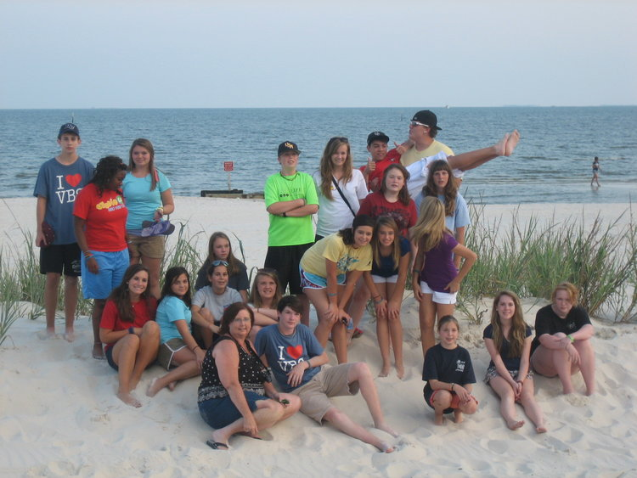

Missions on the Mississippi Gulf Coast
God is working on the Mississippi Gulf Coast and we want to invite you and your church to join us as we join Him in reaching the lost and unchurched in Harrison, Hancock and Stone Counties. Of the 270,00 who live here, 80% (215, 505) are unchurched.
Gulf Coast Baptist Association provides mission teams with the opportunity to partner with both new church plants and struggling churches to provide Backyard Bible Clubs, Mission VBS, sports camps and other ministry choices. Partnership Gulf Coast (PGC), our summer missions program, has been host to over 125 mission groups from Oklahoma to Maryland, from Mississippi to Illinois.
Would you like to know more? Click here or contact Dionne Williams at dionne@gulfcoastba.com or call him at 228-832-4311 or call or text him at 228-233-9833.

Partnership Gulf Coast 2020 Housing Info And Available Dates
Gulf Coast Baptist Association (GCBA) provides housing for mission teams participating in Partnership Gulf Coast (PGC). There are two facilities on our campus in Gulfport. Both have bunkbeds, showers, washer/dryer, large meeting room and kitchen with icemaker. The cost is $12 per person per night. One facility will house approximately 30 and the other 48 with room to get a few extra cots in. You cook your own food with a Sam’s Club 8/10ths of a mile away as well as a Neighborhood Walmart. GCBA also provides the BBC material and the plans for a basketball and soccer camps (for this information, click here). PGC can host two teams per week, each in a separate facility. Teams usually come on Sunday and leave on Saturday but we are willing to work with you on your schedule.
These available dates are correct as of 8/13/2020.
May 31 – June 6
June 7 -13
June 14-20
June 20 -27
June 28 –July 4
July 5 -11
July 12 – 18
July 19 – 25
July 26 – August 1

Partnership Gulf Coast Resources And Information
Here are some handy resources to help make your Partnership Gulf Coast experience the best it can be. We are happy to provide you the lessons for Backyard Bible Clubs in PDF form so you can download and duplicate as you need. You will also find evangelism helps and block party ideas.
BBC Bible Stories (2 per session - 1 NT and 1 OT)
Jesus’ Birth  Jesus Feeds the Multitudes  Jesus Calms the Storms  Jesus Is Alive | Day and Night, Sky and Water  Dry Land and Sea  Land and Water Creatures  People Work and Rest
Other Resources (click to download)
Telling Mississippi Children About Jesus
Block Party Manual (NAMB)
Other Ministry Opportunities on the Gulf Coast
Feel free to add one of these other mission experiences to your trip during your free time. The links provided below will give you contact information to the ministry. You will need to contact the ministry directly to set up a time to help.
International Seamen Center (website)
Gulf Coast Community Ministries - 3914 15th St, Gulfport, MS 39501 Hours: Tuesday9–11AM and Thursday9–11AM Phone: (228) 868-8202
Gulf Coast Rescue Mission - 2750 Mission Ln, Biloxi, MS 39531 Phone: (228) 388-3884
Feed My Sheep
Places to Eat and Fun Places to Go
Where To Have Fun Page
Gulfport Restaurants
El Aguave’s  White Cap  MugShots  Shrimp Basket  Buffalo Wild Wings | Azteca’s  Felix’s  El Saltillo  Half Shell Oyster House  Patio 44 Koi (Hibachi grill) | Tony’s Brick Oven Pizzeria  Royal Supper Buffet (Chinese)  Salute’s  Shaggy’s
Long Beach Restaurants
Steve’s Marina  HarborView | Darwell’s  Cajun Crawfish Hut | Juan Tequila’s
Biloxi Restaurants (has some of the same as Gulfport)
McElroy’s  Snapper’s | Wentzell’s  Saltgrass | Blind Tiger

