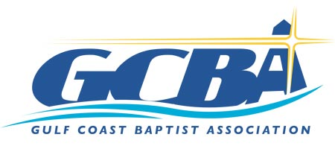 Partnership Missions Funding Request Form

Date _____________________

Church Name ________________________________________________________________________

Mission Trip (Missions OUTSIDE the GCBA area)
Date of Trip ____________________
Where are you going? _________________________________________________________________
How many people are going from your church? __________________
What will you be doing? _______________________________________________________________

____________________________________________________________________________________
Amount of Request: ______________________
(up to $100.00 per person per year and a maximum of $1,000.00 per church on an annual basis)

Local Missions/Evangelistic Project (within the GCBA area)
Date of the event _______________________________
Where will the event be held? ___________________________________________________________
Who is your target? ____________________________________________________________________
Amount Requested ______________________ (a maximum of $300.00 per church, per year)

By signing, I agree that I have read the GCBA Partnership Missions Policy printed on the reverse side.

Pastor’s Signature ____________________________________________________________________
(Please present your request no less than 30 days prior to your event.)
Email form to steve@gulfcoastba.com.
GCBA Partnership Policy
The GCBA will partner with GCBA churches to provide funds to assist them with mission trips, missions/ministry and
evangelistic projects.
1. Funds will be available on a “first come, first served” basis.
2. Requests will be granted on a “funds available” basis.
3. For mission trips the GCBA will assist with up to $100.00 per person per year and a maximum of $1,000.00 per church on an annual basis.
4. Funding for local missions/ministry and evangelistic events will be a maximum of $300.00 per church, per year.
The procedure will be as follows:
a. The Pastor or his designee will complete a “Partnership Missions Funding Request” form (available as download at www.gulfcoastba.com)
b. Form will be submitted to the AMD
c. AMD will submit the request to the Finance Team for approval.
d. When approved, the Financial Assistant will be given the authority to issue a check.
e. When the trip/event is concluded, the partnering church is encouraged to provide a praise report to the Association office for inclusion in association publications describing how God blessed the event.
f. Preference will be given to churches which support the GCBA financially. Exceptions to this will be considered by the Executive Team (e.g., a new Church Plant or a church experiencing financial difficulties)

